Overview
North Carolina State University’s Centennial Campus functions as a microgrid campus that integrates a district heating and cooling system, a combined heat and power (CHP) system, thermal energy storage, solar photovoltaic (PV) generation, and battery energy storage systems (BESS) as distributed energy resources (DERs). Through advanced metering infrastructure and building automation systems (BAS), campus building loads can be continuously monitored and controlled, supporting optimized energy operation and grid-interactive functionality. This makes Centennial Campus a valuable testbed for research aimed at improving energy efficiency, demand flexibility, and resilience. Our team is currently developing digital twin models of the campus buildings and district heating and cooling systems to support advanced simulation, control, and validation studies. Requests for information related to the campus digital twin building models should be directed to Dr. Soolyeon Cho, Director of the Building Energy Technology Laboratory (BETlab), at scho3@ncsu.edu.

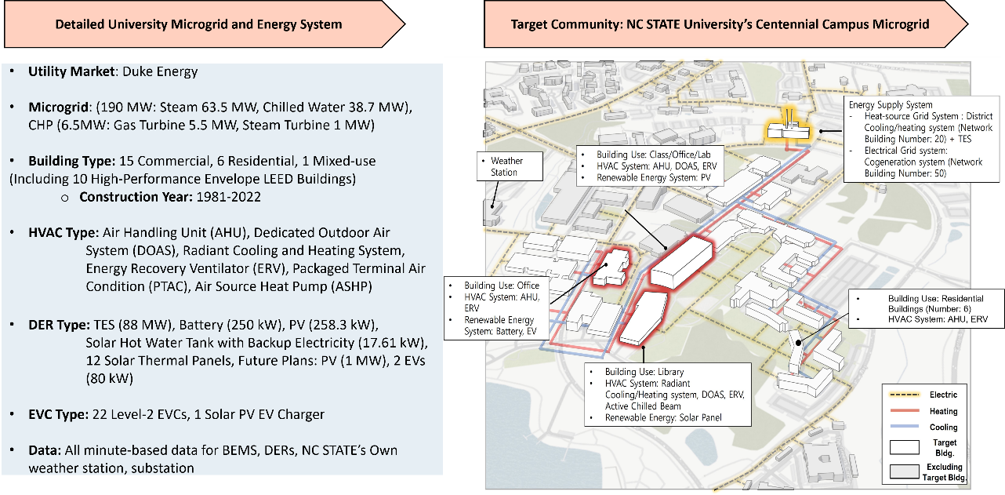
Figure 1. NC STATE Centennial Campus Overview
Fitts-Woolard Hall (FWH) Building
FWH is a four-story academic building located on Centennial Campus at North Carolina State University. The building was completed in 2020 and serves as a modern facility for education and research. The building has a design heating load of approximately 5,300 MBH and a cooling load of approximately 1,100 tons. It is served by a district heating and cooling system. The HVAC system consists of Variable Air Volume (VAV) systems with terminal reheat coils, supported by Dedicated Outdoor Air Systems (DOAS). Air Handling Units (AHUs) are equipped with economizers, allowing the use of outdoor air for cooling when conditions are favorable. This system configuration supports efficient operation and indoor environmental control.
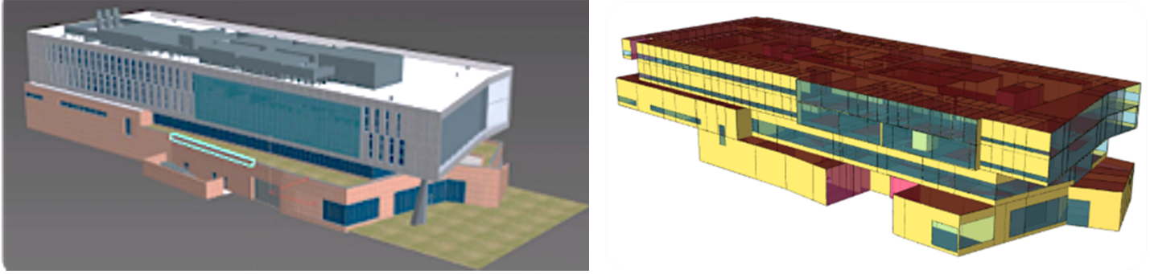
EnergyPlus Model Description
The EnergyPlus model represents the full building of Fitts-Woolard Hall, including all floors and occupied spaces, with 465 rooms aggregated into 226 thermal zones. The building is served by a district heating and cooling system, modeled using DistrictHeating and DistrictCooling components to represent centralized energy supply without detailed plant modeling. The air-side HVAC system consists of four Air Handling Units (AHUs). AHU-1, along with exhaust fans, serves laboratory spaces, while AHU-2, AHU-3, and AHU-4 serve general spaces with support from Dedicated Outdoor Air Systems (DOAS). The system includes VAV terminals with reheat and AHU economizers. Indoor temperature setpoints are 70°F for heating and approximately 69.8°F (21°C) for cooling, enabling simulation-based analysis of building energy performance and system behavior.
Semantic Modeling of Fitts-Woolard Hall
This work presents a semantic modeling and validation framework for HVAC systems using real Building Automation System (BAS) data from Fitts-Woolard Hall. The study focuses on a Dedicated Outdoor Air System (DOAS) and integrates the Brick schema with ASHRAE Standard 223P to represent equipment, sensors, and time-series data. Using SHACL constraints, the framework validates data consistency and compliance with operational rules from ASHRAE Guideline 36. The results demonstrate that the system satisfies validation requirements and highlight the potential of semantic modeling for HVAC control, fault detection, and digital twin integration.
Reference
Yujin Kim, Juwan Ha, Seungmin Lee, Soolyeon Cho. (2026) Ontology-Based Semantic Modeling of HVAC Systems in the Office Building: A Foundation for Scalable Control and Digital Twin Integration, 2026 ASHRAE Winter Conference, Las Vegas.
Wolf Ridge Apartments and Industrial Building
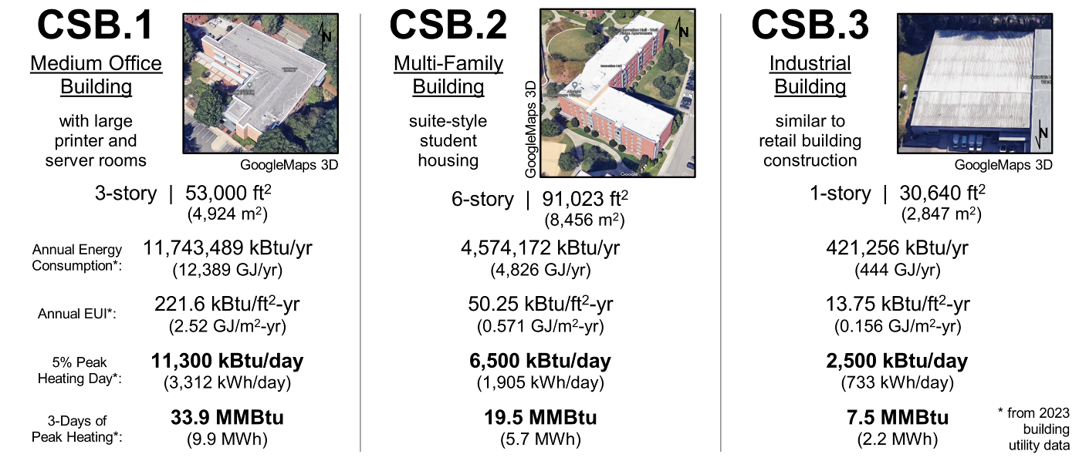

This study uses the developed digital twin models to evaluate the performance of the proposed Building Thermal System (BTS) across three real case-study buildings with different functions and structural characteristics: a mid-sized institutional office building, a six-story suite-style student housing building, and a lightweight steel-structure warehouse. The BTS uses rooftop solar thermal collectors as the primary energy source and incorporates a Thermal Mass Energy Storage (TMES) system, in which piping embedded in the soil or sand layer beneath the building foundation functions as a thermal battery. The stored thermal energy is delivered to indoor spaces through a Thermally Activated Building System (TABS) via radiant heat transfer, while a Dedicated Outdoor Air System (DOAS) handles ventilation and latent loads as part of a dual-system architecture. Using actual weather data and utility meter data for steam and electricity, high-fidelity dynamic simulations were conducted at a one-minute resolution for the peak heating period from December 13 to 22, 2023. The results confirm that the proposed system can meet 100% of the heating demand of the case-study buildings using solar thermal energy alone.
Reference
Hawks, M. and S. Cho. 2024. Review and analysis of current solutions and trends for zero energy building (ZEB) thermal systems. Renewable and Sustainable Energy Reviews 2024;189:114028.
Hawks, M. and S. Cho. 2026. Thermal Mass Energy Storage (TMES) Engineering Framework that Enables the Use of Passive and Renewable Energy for Radiant Heating and Cooling Systems. ASHRAE Transactions 132:LV-26-137.
Hawks, M. and S. Cho. 2026. Control Architecture for an Energy Flexible Building Dual Mechanical System with Novel Storage. ASHRAE Transactions 132:LV-26-094.

Building Geometry and Energy Modeling of Hunt Library
The James B. Hunt Jr. Library at NCSU is a flagship academic facility designed to support advanced research, digital scholarship, and collaborative learning. The building features a highly flexible interior layout, extensive glazing, and a technology‑rich environment that integrates visualization labs, maker spaces, and automated book storage systems. Its architectural design emphasizes daylight access, occupant comfort, and spatial adaptability, making it a representative example of contemporary high‑performance academic buildings.
The Hunt Library operates with a modern HVAC configuration that includes variable‑air‑volume (VAV) air handling units, demand‑controlled ventilation, and hydronic heating and cooling distribution. The building incorporates high‑efficiency chillers and boilers connected to the campus district energy network, enabling stable thermal supply and optimized load management. Advanced building automation systems (BAS) support continuous monitoring of indoor environmental conditions, scheduling, and energy‑efficient operation. The Hunt Library building energy model is currently under development.
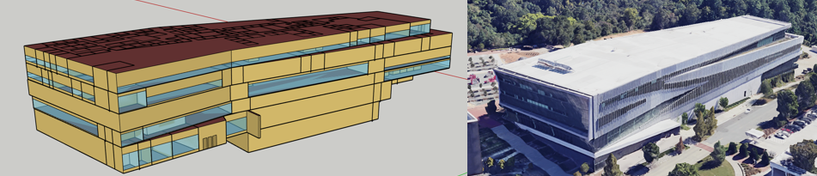

Building Geometry and Energy Modeling of Textile Complex Building
The Textile Complex at NCSU serves as the primary academic and research hub for the Wilson College of Textiles. The facility consists of several interconnected buildings organized around a central courtyard, housing classrooms, research laboratories, pilot-scale manufacturing spaces, and industry-engaged extension programs.
From a systems perspective, the complex accommodates laboratory-intensive textile engineering and materials research, requiring specialized HVAC configurations such as high-capacity ventilation, humidity-controlled environments, and dedicated exhaust systems for dyeing, chemical processing, and fiber fabrication. Public and multipurpose spaces – including atria and event areas – are supported by campus-standard building automation systems (BAS) that manage air distribution, lighting, and environmental stability. The Textile Complex Building energy model is currently under development.
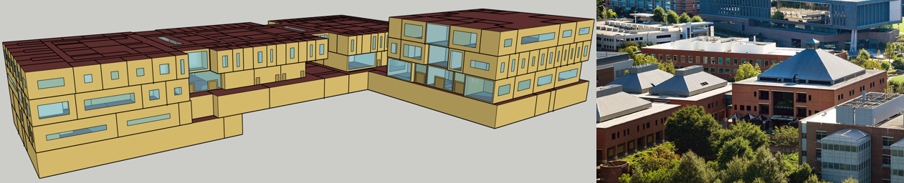

Building Geometry and Energy Modeling of Solar House
The NCSU Solar House is a demonstration residence designed to showcase passive and active solar design strategies, renewable energy integration, and sustainable residential construction. The building incorporates a compact form, optimized solar orientation, and a combination of passive heating, shading, and natural ventilation features. Its architectural configuration supports hands-on research and education related to residential energy performance, renewable technologies, and building-scale sustainability strategies.
The Solar House’s mechanical and electrical systems are centered around solar energy utilization, including rooftop photovoltaic (PV) panels and solar thermal collectors for domestic hot water. The HVAC system typically consists of a high-efficiency heat pump, supplemented by natural ventilation and envelope-driven thermal performance. Energy monitoring equipment and small-scale control systems enable real-time measurement of electricity generation, thermal loads, and indoor environmental conditions. The Solar House building energy model is under validation process.
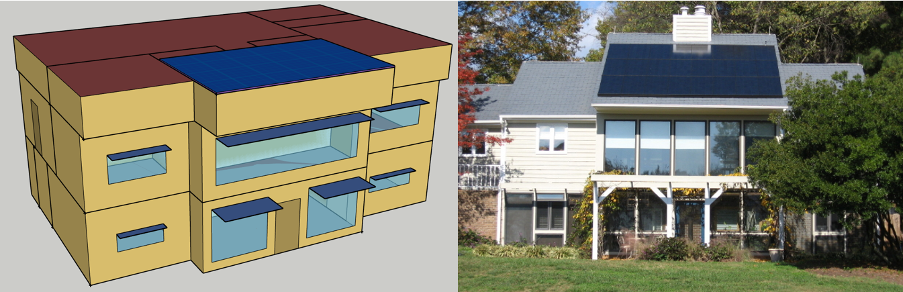
Etc
Physics-Informed Neural Networks (PINNs) Model
The Physics-Informed Neural Network (PINN) model combines data-driven learning with physical principles, such as thermodynamics and heat transfer, to predict building thermal dynamics with improved accuracy and data efficiency. By integrating calibrated EnergyPlus simulation data with an RC thermal network model, the PINN can maintain physical consistency while requiring less training data than a purely data-driven model. When coupled with Model Predictive Control (MPC), it enables optimized HVAC setpoint control and improved cooling energy efficiency.

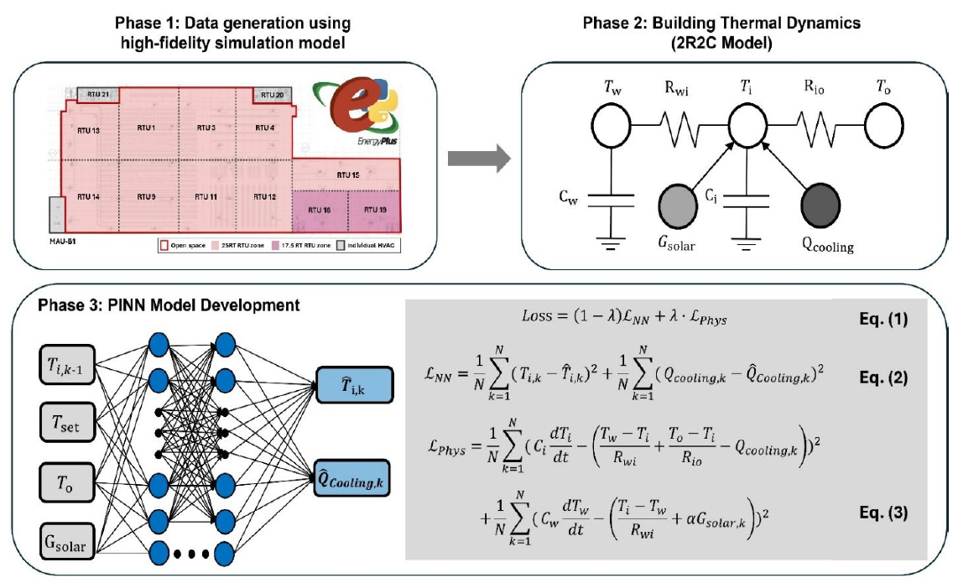
References
- PINNs Model
  - Juwan Ha., Seungmin Lee., Yujin Kim., & Soolyeon Cho. (2025). Improving energy and data efficiency in factory building: A physics-informed neural networks-based model predictive control (PINNs-based MPC) approach. ASHRAE Transactions, 131, 670–678.
Commercial Building
- VRF-HP System
  - Seo, B., Yoon, Y. B., Yu, B. H., Cho, S., & Lee, K. H. (2020). Comparative analysis of cooling energy performance between water-cooled VRF and conventional AHU systems in a commercial building. Applied Thermal Engineering, 170, 114992.
- AHU System
  - Seo, B., Yoon, Y., Lee, K. H., & Cho, S. (2023). Comparative analysis of ANN and LSTM prediction accuracy and cooling energy savings through AHU-DAT control in an office building. Buildings, 13(6), 1434.
Residential Building
- Double Skin Facades
  - Yoon, Y., Seo, B., Mun, J., & Cho, S. (2023). Energy savings and life cycle cost analysis of advanced double skin facade system applied to old apartments in South Korea. Journal of Building Engineering, 71, 106535.

